Name__________________________ Block_____

1) Reflect on the picture.
Why would the author include this picture?

2) How does the picture impact the reader?

3) Based on the 1st section, what is the author's purpose, or overall goal, in writing this article? Draw an arrow to the one piece of evidence that most strongly supports your answer.

Annotate (take notes on) your text here AS YOU READ . Stop at each number and answer the appropriate question. You must use textual evidence.

Newsela

Sleeping under a roof, but homeless nonetheless
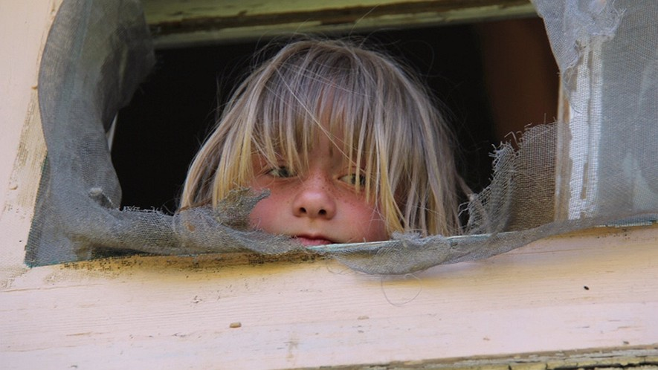
By Addie Morfoot
Ten-year-old Kaylie Hegwood and her brother Tyler, 12, are hungry – very hungry. Not because they just finished a game of soccer or forgot to eat breakfast. Kaylie and Tyler are hungry because most of the time their mom cannot afford to buy them food for breakfast, lunch and dinner.
Figure 1Kaylie Hegwood looks out a window from the home her family is forced to leave. 1 and 2
“There’s good days and bad days,” Tyler told Jezza Neumann, the director of the PBS documentary “Poor Kids.” “Sometimes when we have cereal, we don’t have milk. We have to eat it dry. Sometimes we don’t have cereal and we have milk. It’s often, like, switch and swap. Sometimes, like, when I switch the channel and there’s a cooking show on, I get a little more hungry and I want to vanish into the screen and start eating the food.”
Kaylie and Tyler live with their mother, Barbara, in Iowa. Even though Barbara is employed, she has very little money left for groceries after paying the rent. Kaylie and Tyler try to help their mother by both collecting empty cans to recycle and by mowing lawns. Kaylie and Tyler do not attend school because they do not have a permanent home. They move too frequently to register at a school. Currently they are living in a motel. They are homeless. 3
4) The central idea of the section "Who Are The Homeless" is "Homelessness among children is a growing problem and epidemic in America." What evidence in the section supports the central idea? Explain and circle the evidence.

5) Underline the first sentence of the “Childhood is Critical” section: How does the author develop and prove this underlined idea? Explain and draw boxes around the evidence that proves the idea.

Annotate (take notes) your text here AS YOU READ

Who Are The Homeless?
Say the word “homeless” and many people imagine a ragged-looking adult perched on a sidewalk begging for money. But this is not always the case. Children are also victims of homelessness.
Studies say that 16 million children in America live in poverty, a condition of having little or no money, goods or means to support oneself. Poverty leads to homelessness, which is why one in every 45 children in the United States, or more than 1.6 million children, do not have a place to call home. That is equivalent to the entire population of the state of Idaho. This is why in March 2011 the Congressional Caucus on Homelessness hosted a briefing on family homelessness called "A Growing Epidemic: Homeless Children, Youth and Families." An “epidemic” describes something that is growing or spreading rapidly, usually with unwanted or bad results. 4

No Pocket Money To Spare
“A lot of times, I have to give my money up to buy groceries and buy gas for the car and lawn mower for mowing other people’s lawns,” Tyler tells Neumann. “I got $10, and I put in $6 of it for the gas and gave the rest to my mom for some food. And (that’s) kind of what I do with my money.”
Kaylie and Tyler are not alone in their struggle to help their mother make enough money to survive. According to national studies, millions of Americans pay more than 50 percent of their income on rent and utility bills. Barbara’s income is $1,480 and her total bills each month are $1,326. That leaves her with just $154 to spend on gas for the car and food for herself and her two children each month. Unexpected events like a missed paycheck, an illness or car trouble can spiral into a crisis that forces a family to give up its home and live on the street, in a shelter or in a cheap motel like Kaylie and Tyler.

Childhood Is Critical
The more time children like Kaylie and Tyler live in poverty, the harder it will be for them to not be poor as adults. One main reason is that children who face poverty and homelessness have a hard time attending school because they are more likely to have to work to help their parents pay the bills. According to Columbia University’s National Center for Children in Poverty, 45 percent of people who spent at least half of their childhood in poverty were poor at age 35. Among those who spent less than half of their childhood in poverty, only 8 percent were poor at age 35.
6) Look back at your answer to the 3rd question. After reading the whole article, what is the author's purpose?

7) What is the author's perspective or point of view on the impact of homelessness?

QUESTION 8:
Answer this question using the rest of the blank space of this page
Annotate (take notes) your text here AS YOU READ
Studies indicate that homeless children are twice as likely as non-homeless kids to experience anxiety as well as depression. Studies also show that one in six homeless kids will develop emotional problems and 25 percent will witness violence.
Data from the Organization for Economic Cooperation and Development shows that the United States has one of the highest child poverty rates among developed countries. Of the 34 countries ranked by the OECD, only Mexico, Chile and Turkey have higher child poverty rates. 5 (previous page)

Homeless But Hopeful
Film directors Sean Fine and Andrea Nix Fine shed light on the epidemic in 2012. Their short documentary, "Inocente," about a 15-year-old homeless girl named Inocente Izucar aired on MTV. Inocente, who moved more than 30 times in nine years, used her artistic talent to escape her circumstances.
"In a normal school classroom in the U.S., there are 22 kids. So if you take two classrooms, one kid is going to be homeless. And if you think about all the classrooms in the U.S., that's a lot of kids," Sean Fines told Vice.com reporter Jamie Lee Curtis Taete.
"Inocente" won an Academy Award in 2013. The directors are counting on publicity from the Oscar win to bring more attention to the subject. They hope the film, just 40 minutes in length, will be shown in museums and libraries and become part of school curriculums in order to aide in the discussion about this epidemic. 6 and 7
8
According to the article, how can experiencing homelessness impact a person’s identity? Include text evidence that supports your answer! Use the back if needed.

