**BEING RESPONSIBLE, READY, AND RESPECTFUL**

**HOW WE WILL MANAGE OUR CLASS TOGETHER**

All students are entitled to a safe, comfortable learning environment.

The two rules we need to follow to ensure that happens for everyone are:

**RESPECT ALL**

**And**

**BE KIND TO EACH OTHER**

Below are behavior expectations for class including, but not limited to:

**Respect Yourself**

• Bring all necessary materials to class every day and if you forget, get them from class supplies upon entering class.

• Be in your seat before the tardy bell rings.

• Come to class meeting the dress code.

• Pay attention to and follow directions

• Use our time wisely.

• Accept responsibility for your actions.

**Respect Others**

• Do not touch, poke, prod, mangle, mutilate or otherwise put your hands, feet, pencils, pens, penguins, marmots, platypuses…or ***any other object*** on someone else.

• Remain quiet and attentive while your teacher, another adult, or a classmate is speaking.

• Speak respectfully to teachers and other students.

• Keep unnecessary comments to yourself.

• Work together to solve problems.

**Respect Property**

• Keep non-educational property in your locker, especially:

-Grooming materials (brushes, make-up, lotion/perfume bottles)

-body spray

-toys

• Please do not write on books, desks, computers, and equipment.

• You may bring **water** and snacks to class as long as it does not become a distraction or make a mess.

• Pick up after yourself and put trash in appropriate containers.

**OTHER THINGS YOU SHOULD KNOW**

• Use your class change time wisely!!

•Once in the room, find your seat and get ready for class. All pencils should be sharpened and your materials should be out and ready to go.

• Students may get up QUIETLY, without permission (if the privilege is not abused), for pencil sharpener, tissues, and asking questions of the teacher.

•As long as students respect each other’s voices, students do not need to raise hands unless a guest or sub is teaching the class or your teacher has specifically asked for it. **This is a responsibility you must treat with care.**

•The bell tells your teacher when you are late and it tells your teacher when class is technically over. Your teacher dismisses class. The bell does not.

You are ultimately responsible for your learning. How you approach our class will determine what you learn from it.

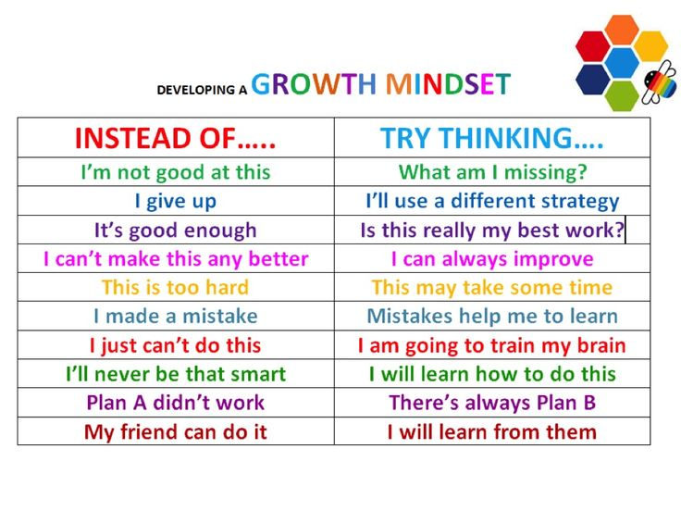Come to class with a growth mindset everyday: It’s not that you can’t do it, it’s just that you can’t do it yet. The chart below will give you a starting place:

**AND FINALLY,**

**LEAVE DRAMA IN THE HALL.**

**THIS IS A DRAMA FREE SPACE! (unless we’re acting! ☺)**



**How Ms. L will help you succeed with your behavior:**

1. **I will both work hard to make lessons engaging and relevant.**
2. **I will get to know you and what you need in class.**
3. **I will stay close and wander throughout the classroom to help you stay on task.**
4. **I will listen when you have a problem and try to help you fix it if that’s what you want.**
5. **I will respect you and treat you like the young adult you are.**
6. **I will not yell (I will try not to yell).**
7. **I will not call you out in front of your classmates without just cause.**

**No one is perfect, and there will be times when we make the wrong choices, even me! This is ok. We learn from our mistakes. However, we must also own our mistakes and the consequences for them.**

**\***Consequences for Bad Choices in Class:

1. 2 warnings
2. Seat change
3. Lunch detention in classroom and Email/Phone call home, email to coach if you are an athlete.
4. Removal from classroom and a minor referral (plus #3)
5. ASD (after school detention) and an email/phone call to parents and coaches if behavior continues in the classroom you are sent to or it is a repeated problem.

**(Please be aware that if you play a sport, your ASD will either be a practice day or a game day. You are a student athlete and as such, have the added responsibility of providing a good example for others.)**

1. Major Referral

***steps 3-6 all require a student/teacher conference.

**Mr. Langlois reserves the right to skip steps if necessary.**

**Please make good choices for both your own learning and your classmates’ learning!! It is you and your behavior that determines what our class will look like**

**everyday.**