Instructions for close reading of empathy article: All work to be done with a partner except #4
1) Read the article once all the way through, and underline any words you do not know.
Check this box when you are done. DO NOT MOVE FORWARD WITHOUT CHECKING THIS BOX AS FINISHED!
2) Re-read the text and annotate your text with a summary for each bold headed section. (Please follow the
instructions found on the article BUT DO NOT DO THE LAST QUESTION UNTIL STEP 4
Check this box when you are done. DO NOT MOVE FORWARD WITHOUT CHECKING THIS BOX AS FINISHED!
3) Go back through the text and circle the pieces of evidence in each section that support
your summary of that section.

Check this box when you are done. DO NOT MOVE FORWARD WITHOUT CHECKING THIS BOX AS FINISHED!
4) Answer the final question on the empathy article handout, and turn in to the late work box.

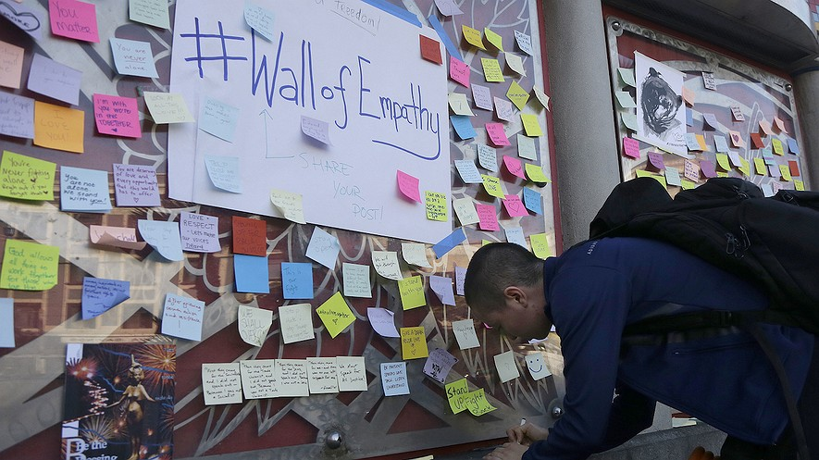
A sticky note is filled out to be placed on "Wall of Empathy" at a Bay Area Rapid Transit station in San Francisco, California, November 14, 2016 to show support for people who have to live with racism.
After each Bold Headed section, write a 6-9 word summary of what you have just read.

Explainer: What is empathy?

Sympathy Is A Different Emotion

Explainer: What is empathy?

By The Conversation, adapted by Newsela staff
04/13/2017
Empathy is the ability to share and understand the emotions of others. It is constructed of multiple parts, each of which is associated with its own brain network.
There are three ways of looking at empathy. First there is affective empathy, which is the ability to share the emotions of others – for example, someone watching a scary movie may feel scared when a character is scared.
Second, there is cognitive empathy, or the ability to understand the emotions of others. A good example is when a psychologist listens to her client and understands his emotions, but does not necessarily share them.
Finally, there’s emotional regulation, which refers to the ability to control one’s emotions. For example, surgeons need to control their emotions when operating on a patient.

Sympathy Is A Different Emotion
Empathy is not the same thing as mimicking someone else's emotions, nor is it sympathy. Sympathy involves feeling concern for the suffering of another person and a desire to help.
People often say psychopaths lack empathy but actually, they lack sympathy – they know when someone is suffering, but they just don’t care. Research has also shown that they are often very good at regulating their emotions. Empathy has been observed in many non-human primates and even rats.
After each Bold Headed section, write a 6-9 word summary of what you have just read.

Helps us Respond to Different Situations

Measuring Empathy

Helps Us Respond To Different Situations
Empathy is important because it helps us respond appropriately to different situations. There is research showing that greater empathy leads to more helping behavior, but this is not always the case. For example, someone who sees a car accident and is overwhelmed by emotions might be less likely to help the person in pain.
Empathy may not always be good – strong empathetic feelings for members of our own family or our own social or racial group might lead to hate toward those we see as a threat. People who are good at reading others’ emotions might also deceive others for their own benefit.

Measuring Empathy
Empathy is often measured with self-report questionnaires. These typically ask people to indicate how much they agree with statements that measure different types of empathy.
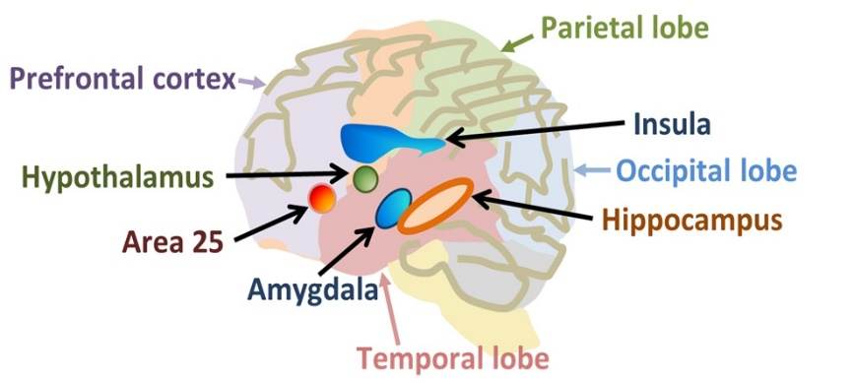
For example, the questionnaire measures affective empathy by asking someone to agree or disagree with the statement, “It affects me very much when one of my friends is upset.” “I try to look at everybody’s side of a disagreement before I make a decision," would measure cognitive empathy.
There may be physical differences between people with different empathy levels. People who score higher on affective empathy have more grey matter in one part of their brain. Meanwhile, people who score higher on cognitive empathy had more gray matter in a different area. Gray matter is a collection of different types of nerve cells, which are excitable with electricity.
After each Bold Headed section, write a 6-9 word summary of what you have just read.

Selective Empathy

Selective Empathy

Studying Brain Activity

Research shows we typically feel more empathy for members of our own group, such as people who look like us. For example, one study scanned the brains of Chinese and Caucasian participants while they watched videos of each other pain. There is an area of the brain that is often active when we see others in pain. It was less active when participants saw members of a different race in pain.
Empathy is linked with social behavior. Research shows that empathetic feelings are strong among social groups like a sports team. Other studies have found brain areas involved in empathy are less active when watching people in pain who act unfairly. People even experience pleasure when a rival sport team fails.
In some situations, it could be helpful to feel less empathy. For example, in war it might be beneficial to feel less empathy for people you are trying to kill.

Studying Brain Activity
To investigate, we did a study asking people to watch videos from a violent video game. In the game, a person was either shooting innocent civilians (unjustified violence) or enemy soldiers (justified violence). While watching the videos, people had to pretend they were killing real people.
A brain area active when we harm others was active when people shot innocent civilians. The same area was not activated when people shot the soldier that was trying to kill them.
The results we found provide a look into how people regulate their emotions and how people become desensitized to violence. It may also help explain why some people feel more or less guilty about harming others. Yet, we do not always feel less empathy for those who aren’t members of our own group. To investigate, we did another study where students had to give either money or painful electrical shocks to students from the same or a different universit
After each Bold Headed section, write a 6-9 word summary of what you have just read.

In-Group Biases
Brain areas involved in rewarding others were more active when people rewarded members of their own group. However, areas involved in harming others were equally active for both groups. These results correspond to observations in daily life. We generally feel happier if our own group members win something, but we’re unlikely to harm others just because they belong to a different group, culture or race. In general, in-group bias is more about in-group love rather than out-group hate.

In-Group Biases

Our empathetic brain has evolved to be highly adaptive to different types of situations. Having empathy is very useful, as it often helps to understand others so we can help or deceive them. However, sometimes we need to be able to switch off our empathetic feelings to protect our own lives and those of others.

Pascal Molenberghs is a senior lecturer in social neuroscience at Monash University in Melbourne, Australia.
ANSWER THIS QUESTION USING CER.
What is the central idea of the article. Use at least two details from the article to support your response.
_____________________________________________________________________________
_____________________________________________________________________________
_____________________________________________________________________________
_____________________________________________________________________________
_____________________________________________________________________________
_____________________________________________________________________________

