Get your computer up and running and get to work Bellwork October 30-November 2 Name_______________ Block______
You should be working on or very close to working on bellwork when the tardy bell rings. If you finish before your classmates, you MUST read. Write a birthday haiku for Ms. L somewhere on this paper for an extra 10 points (I won’t tell you what a haiku is; you have four days to figure it out).
ALL WORK MUST BE DONE IN COMPLETE SENTENCES WITH APPROPRIATE PUNCTUATION. IF YOU NEED HELP, ASK
Monday, October 30 Quizlet: Open your computer and go to your vocabulary homework. Write down three of the most interesting words you see. Then write one synonym and one antonym for each word you wrote.
Word: _________________Synonym ___________________ Antonym: __________________
Word: _________________Synonym ___________________ Antonym: __________________
Word: _________________Synonym ___________________ Antonym: __________________

Tuesday, October 31 Vocabulary in context from the master of creepy stories.
Directions: Directions: Read the paragraph and determine the meaning of the underlined word using cross sentence and context clues. USE CER STRATEGY.
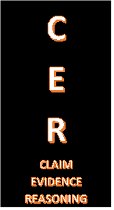

Annabel Lee
BY EDGAR ALLAN POE
It was many and many a year ago,
In a kingdom by the sea,
That a maiden there lived whom you may know
By the name of Annabel Lee;
And this maiden she lived with no other thought
Than to love and be loved by me.

I was a child and she was a child,
In this kingdom by the sea,
But we loved with a love that was more than love—
I and my Annabel Lee—
With a love that the winged seraphs of Heaven
Coveted her and me.

And this was the reason that, long ago,
In this kingdom by the sea,
A wind blew out of a cloud, chilling
My beautiful Annabel Lee;
So that her highborn kinsmen came
And bore her away from me,
To shut her up in a sepulcher
In this kingdom by the sea.

The angels, not half so happy in Heaven,
Went envying her and me—
Yes!—that was the reason (as all men know,
In this kingdom by the sea)
That the wind came out of the cloud by night,
Chilling and killing my Annabel Lee.

But our love it was stronger by far than the love
Of those who were older than we—
Of many far wiser than we—
And neither the angels in Heaven above
Nor the demons down under the sea
Can ever dissever my soul from the soul
Of the beautiful Annabel Lee;

For the moon never beams, without bringing me dreams
Of the beautiful Annabel Lee;
And the stars never rise, but I feel the bright eyes
Of the beautiful Annabel Lee;
And so, all the night-tide, I lie down by the side
Of my darling—my darling—my life and my bride,
In her sepulcher there by the sea—
In her tomb by the sounding sea.
C: CLAIM: Sepulcher means______________________________________________________
E: EVIDENCE: I KNOW THIS BECAUSE______________________________________________
_________________________________________________________________________________________________________________________________________________________
R: REASONING: My evidence supports my claim because _____________________________
__________________________________________________________________________________________________________________________________________________________

Wednesday, November 1 Thinking around corners: Rebus Puzzles

A Rebus is a picture representation of a name, work, or phrase. Each rebus puzzle box below portrays a common word or phrase. Can you think around corners to the answer?
Example: Since the word HEAD is over the word HEELS, the answer to the puzzle would be HEAD OVER HEELS! Get it?

___________________________

___________________________

___________________________

____________________________
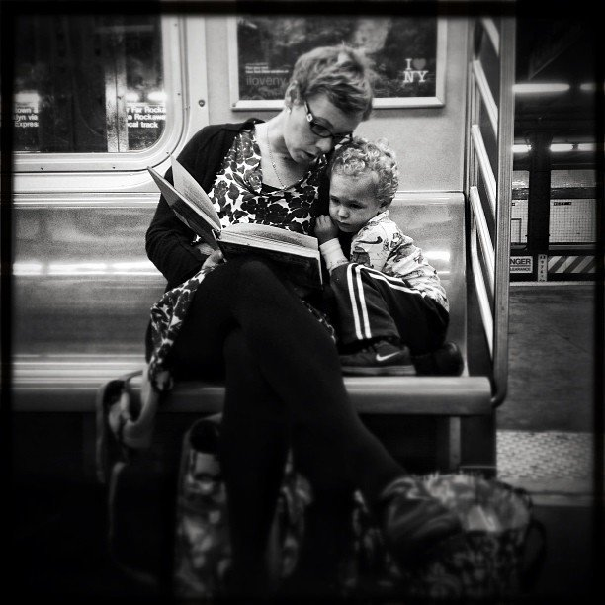

Thursday, November 2 Captioning
Think of writing captions like creating memes. The difference is if the ‘meme’ is good, people will want to read the story that goes with it! They can be serious, funny, mysterious, etc., but they should give enough info to guess what’s going on without just telling us what is obvious.

Write a caption here for the picture on the right (if it sounds like a meme, that’s ok too).

