Get your computer up and running and get to work Bellwork November 6-November 9 Name_______________ Block______
You should be working on or very close to working on bellwork when the tardy bell rings. If you finish before your classmates, read, work on Quizlet, or check your grades.
ALL WORK MUST BE DONE IN COMPLETE SENTENCES WITH APPROPRIATE PUNCTUATION. IF YOU NEED HELP, ASK
Monday, November 6 Quizlet: Open your computer and go to your vocabulary homework. Write down three of the most interesting words you see. Then write one synonym and one antonym for each word you wrote. BE SURE THAT THE WORDS YOU CHOSE HAVE THE SAME DEFINITION AS THE ORIGINAL WORD; MANY WORDS HAVE MORE THAN ONE MEANING AND MANY OF YOU ARE LOSING POINTS FOR CHOOSING THE WRONG WORDS WITH THE WRONG MEANINGS.
Word: _________________Synonym ___________________ Antonym: __________________
Word: _________________Synonym ___________________ Antonym: __________________
Word: _________________Synonym ___________________ Antonym: __________________

Tuesday, November 7 Vocabulary in context from the master of creepy stories.
Directions: Directions: Read the paragraph and determine the meaning of the underlined word using cross sentence and context clues. USE CER STRATEGY.
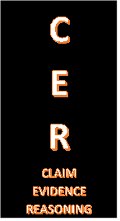
(A Hint: if the word “but” is in a sentence, then what comes right after it will usually be the opposite of something before it….)

The most merciful thing in the world, I think, is the
inability of the human mind to correlate all its contents.
We live on a placid island of ignorance in the midst
of black seas and it was not meant that we should voyage far.
The sciences have hitherto harmed us little; but some
day the piecing together of knowledge will open
up a terrifying reality, and we shall either go mad
from the revelation or flee from the light into the
peace and safety of a new dark age.

Excerpt from The Call of Cthulhu by H.P. Lovecraft

C: CLAIM:means______________________________________________________
E: EVIDENCE: I KNOW THIS BECAUSE______________________________________________
_________________________________________________________________________________________________________________________________________________________
R: REASONING: My evidence supports my claim because _____________________________
__________________________________________________________________________________________________________________________________________________________

Wednesday, November 8 Thinking around corners: Rebus Puzzles

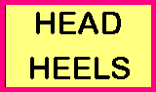
A Rebus is a picture representation of a name, work, or phrase. Each rebus puzzle box below portrays a common word or phrase. Can you think around corners to the answer?
Example: Since the word HEAD is over the word HEELS, the answer to the puzzle would be HEAD OVER HEELS! Get it?
KNEE
LIGHT LIGHTS

___________________________
11111

A TIME

___________________________

HE HE HE HIMSELF
___________________________

- GLANCE
- –
- GLANCE
- GLANCE
____________________________

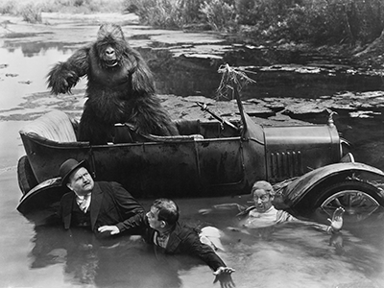
Thursday, November 9 Captioning
Think of writing captions like creating memes. The difference is if the ‘meme’ is good, people will want to read the story that goes with it! They can be serious, funny, mysterious, etc., but they should give enough info to guess what’s going on without just telling us what is obvious.

Write a caption here for the picture on the right (if it sounds like a meme, that’s ok too).

