Get your computer up and running and get to work Bellwork October 1-October 4 Name_______________ Block__
You should be working on or very close to working on bellwork when the tardy bell rings. If you finish before your classmates, you MUST read.
**ATTENTION: ALL WORK MUST BE DONE IN COMPLETE SENTENCES WITH APPROPRIATE PUNCTUATION. ALL WORK MUST ANSWER ALL PARTS OF THE QUESTIONS AND FOLLOW ALL INSTRUCTIONS. WORK THAT DOES NOT MEET THESE REQUIREMENTS WILL BE REDONE UNTIL IT DOES. IF YOU NEED HELP, ASK
Monday, October 1 Quizlet: Open your computer and go to your vocabulary homework. Write down three of the most interesting words you see. Then write one synonym and one antonym for each word you wrote.
Word: _________________Synonym ___________________ Antonym: __________________
Word: _________________Synonym ___________________ Antonym: __________________
Word: _________________Synonym ___________________ Antonym: __________________

Tuesday, October 2 Vocabulary in context
Directions: Read the paragraph and determine the meaning of the underlined word using cross sentence and context clues. USE CER STRATEGY TO EXPLAIN YOUR ANSWER.
C
E
R
CLAIM
EVIDENCE
REASONING
We were so wholly one I had not thought
That we could die apart. I had not thought
That I could move,—and you be stiff and still!
That I could speak,—and you be dumb!
I think our heart-strings were, like warp and woof
In some firm fabric, woven in and out;
Your golden filaments in fair design
Across my duller fibre.
--Edna St. Vincent Millay

C: CLAIM: DUMB MEANS________________________________________________________
_____________________________________________________________________________
E: EVIDENCE: I KNOW THIS BECAUSE______________________________________________
_________________________________________________________________________________________________________________________________________________________.
R: REASONING: I CHOSE THIS EVIDENCE BECAUSE (EXPLAIN HOW IT SUPPORTS YOUR CLAIM ABOVE):______________________________________________________________________
__________________________________________________________________________________________________________________________________________________________

Wednesday, October 3 Thinking around corners: Rebus Puzzles

A Rebus is a picture representation of a name, work, or phrase. Each rebus puzzle box below portrays a common word or phrase. Can you think around corners to the answer?
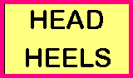
Example: Since the word HEAD is over the word HEELS, the answer to the puzzle would be HEAD OVER HEELS! Get it?
You do the rest:
Lip Lip

___________________________
show

___________________________
Ground
Feet Feet Feet
Feet Feet Feet

___________________________
M1llion

_________________________

Thursday, October 4 Captioning
Think of writing captions like creating memes. The difference is if the ‘meme’ is good, people will want to read the story that goes with it! This is called the loop. Captions don’t tell the whole story, but intrigues the reader and makes them want to read more. They can be serious, funny, mysterious, etc., but they should
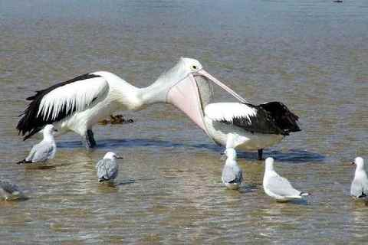
give enough info to guess what’s going on without just
telling us what is obvious.

Write a caption here for the picture on the right (if it sounds like a meme, that’s ok too).

